How to do EDDM mail

1. Go to: [www.usps.com](http://www.usps.com);

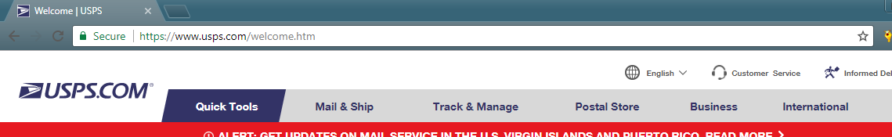

1. Register an account；

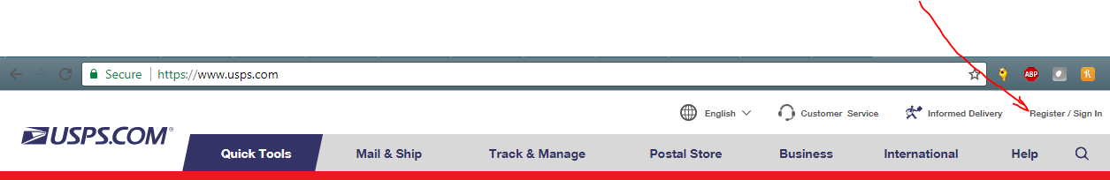

1. After log in, click Business > Every Door Direct Mail;

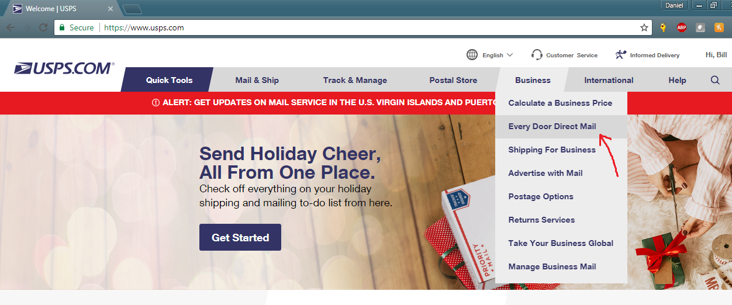

1. Enter the address or zip code at search bar，you will see the area. Zoom in or out, and you will see all the zip codes around that area；

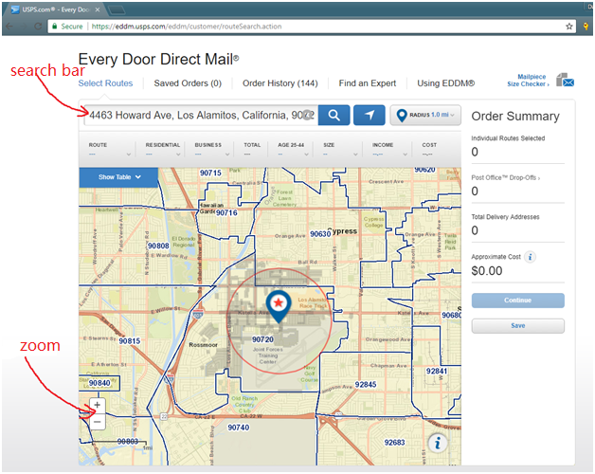

1. There are 2 ways to choose the routes for your mails:

Way 1： Click the route one by one on the map.

On the right hand side, you will see the address count and postage;

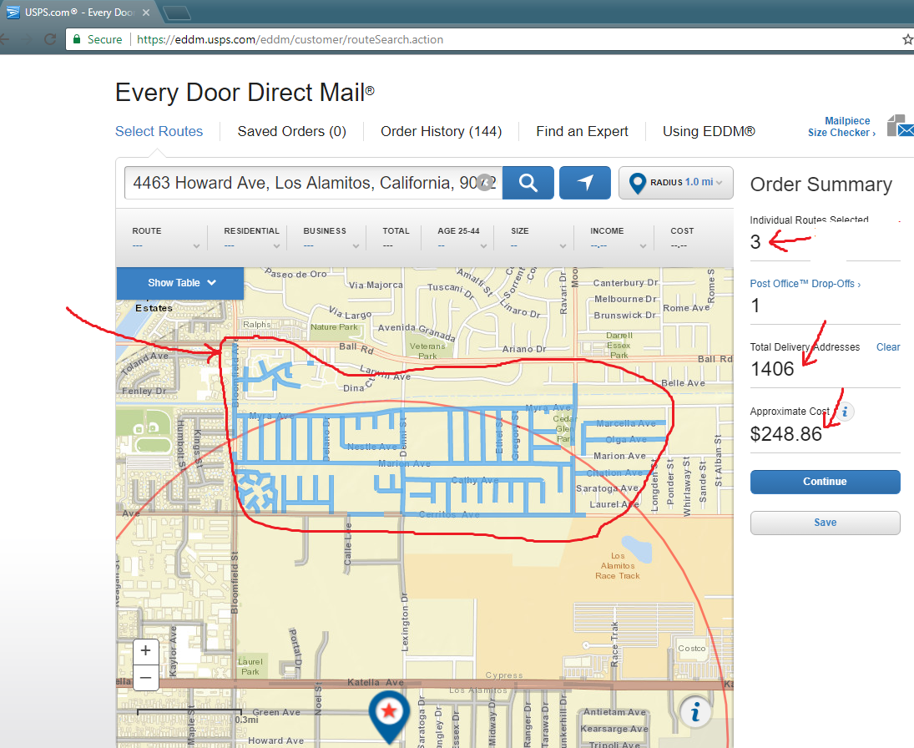

Way 2: You can also chose routes from the route tale:

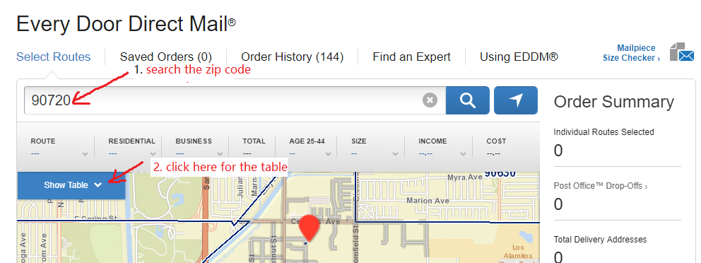

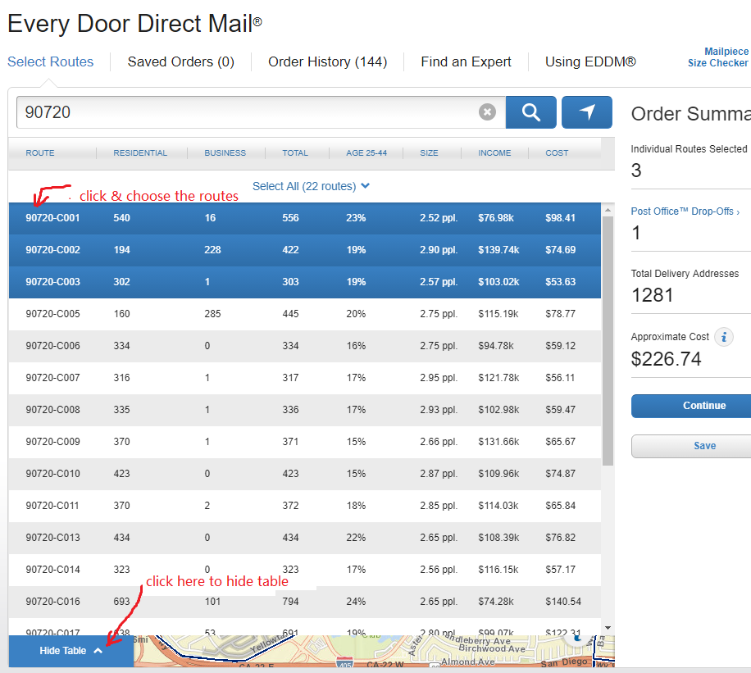

1. Next, choose the mailing date & how to pay:

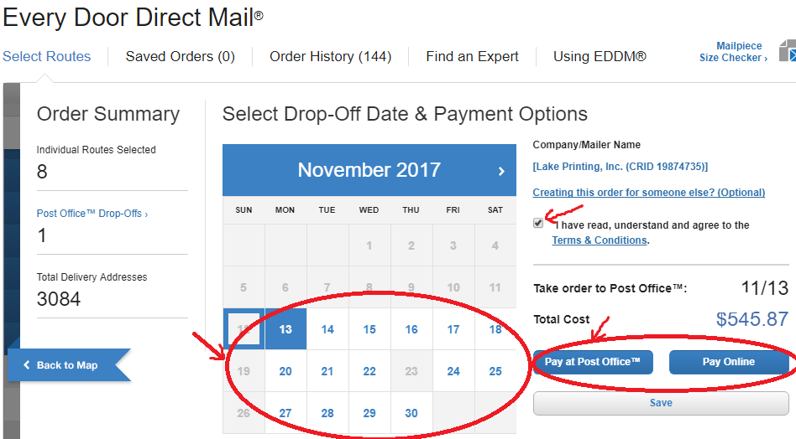

1. Next, print doct & facing slips;

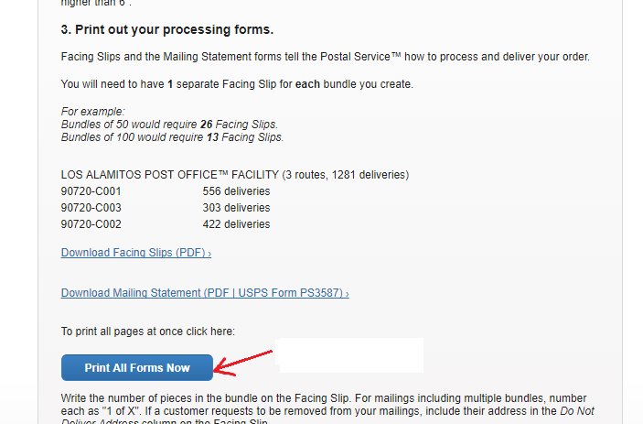

a.The first page shows the post office which will accept the mails:

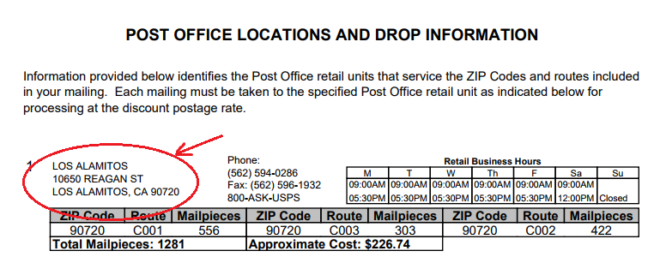

b. Print 2nd page and 3rd page for the post office:

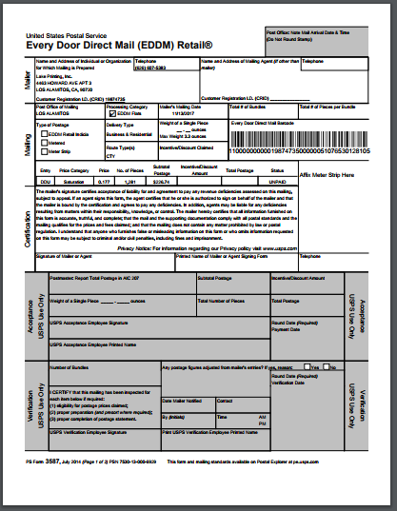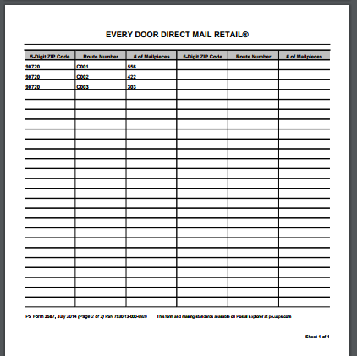

3. Print enough facing slips for each bundle:

For example: route C001 holds 556 addresses，and if the mails is bundle every 100 pcs, then 6 facing slips is needed. Instert one facing slip in each bundle.

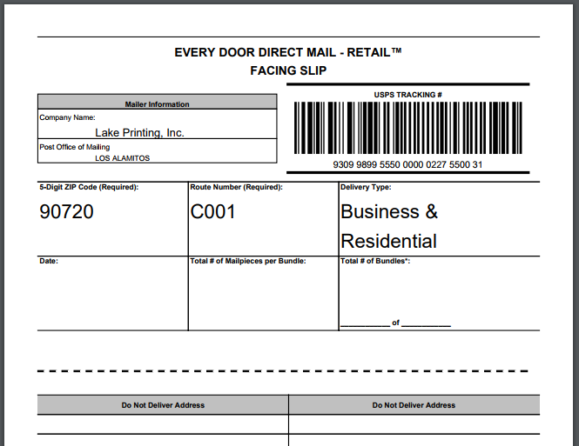

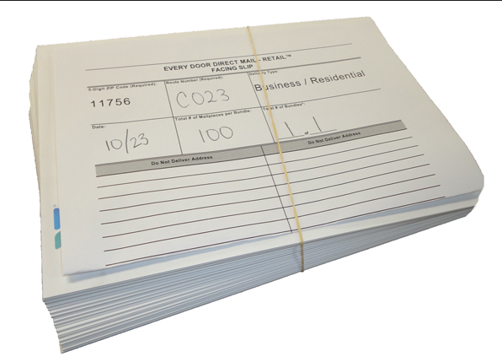

1. Go to a post office and ask for empty trays，you might need 10 trays for one job.

Put mails bundles into trays per the route number. Do not mix mails going different routes in one tray.

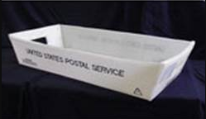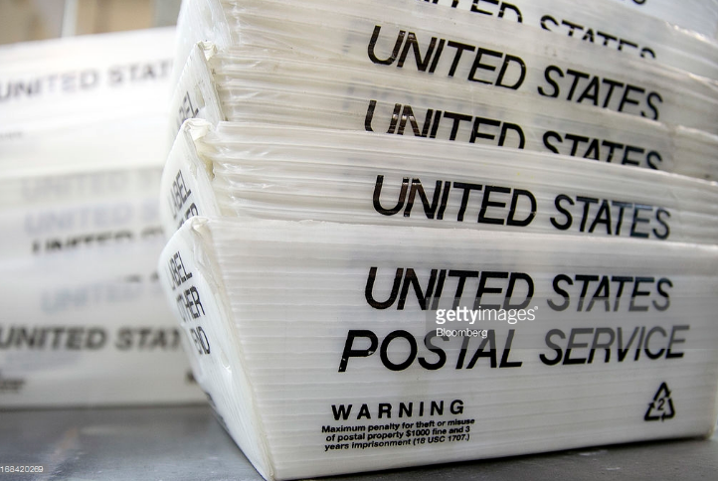

1. Deliver those loaded trays to the post office identified on the 1st page document.

Go to the counter, show them the 2nd page, 3rd page and one sample mail, and pay if you chose to pay in post office. Ask for a push cart if needed, and drop off those loaded trays, and you’re done!

